4
the
TEMPLEBy SBY
“…do you not know that your body is a temple of the Holy Spirit who is in you, whom you have from God, and that you are not your own?”
1Corinthians 6:19

By this time, you are probably on a roll with cutting out sugars. The fact that we are moving slowly, only making one change at a time, increases our chance of being successful. During our last session, you were urged to add protein and more water to your diet. I know that’s two changes, but I think you can handle it! These two changes, plus the reduction of sugar is a tremendous step in the right direction toward better health.
Up to this point, I haven’t mentioned weight loss. Making the simple changes already suggested thus far, should have caused you to drop a few pounds. Weight loss should not be your total focus, but your overall health should be! Listed below are a few ways increasing your protein intake in your diet can promote weight loss.
- Protein Makes You Feel Full
- Protein Curbs Carbohydrate (sugar) Highs & Lows
- Requires More Energy to Digest Protein (You are working out while you chew!)
- Protein Fuels Fat Burning
- Protein Promotes Muscle Repair & Growth
**It’s important to remember, too much of a good thing can be harmful. Too much protein can be harmful to your kidneys over a long period of time. The recommended intake of protein per day is 46 grams for a woman and 56 grams for a man. Before making any drastic changes in your diet, please consult with your physician. Maintaining yearly checkups with your physician is a great way to gain another cheerleader, but also have a professional monitoring your progress, noting any complications that may arise.
7 grams of protein = 1 ounce of cooked meat
Choosing the Right Protein
Generally, the healthiest protein is plant based like the MUFAs, monounsaturated fatty acids, discussed last session. Picking foods like olives or olive oil, avocadoes and nuts, is a great way of eating the healthy protein your body needs. Good meat choices for protein are fish, poultry and lean cuts of beef. Choosing any of these options for your protein is great, only if the sources of these proteins are acceptable. You have to know where your food comes from! Again, this is where reading labels comes in handy. It’s best to eat ...
Organic 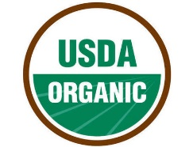 Pesticide Free
Non-GMO 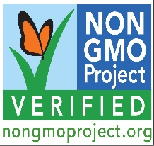 No use of genetically modified organisms
These labels are easy to spot on the products you purchase. Also make sure your protein sources do not contain hormones or antibiotics.
If the foods you consume contain pesticides, GMOs, hormones and/or antibiotics; your risk for many diseases, such as, cancer, diabetes and immune deficiency, is increased.
Typical Diet in the Bible
Lentils, whole grains, (raw) fruits and vegetables, dates, nuts and fish
Try It, You Might Like IT!
Scripture Readings: Ezekiel 47:12; Daniel 1:13-15

